**SQL Subquery assignment**

**Database Schema**

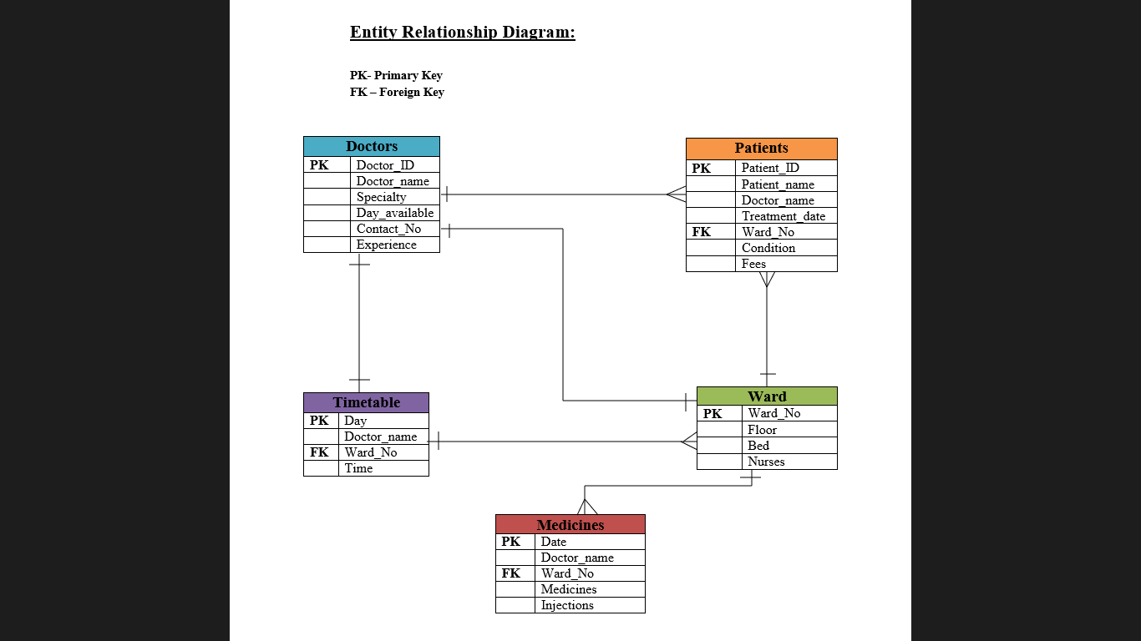

Initial queries for database, table creation and inserting values

Create and use database

create database subqry;

use subqry;

Create Tables

CREATE TABLE Doctors(Doctor_ID int,Doctor_name varchar(30),Specialty varchar(20),Day_Available varchar(20),Contact_No varchar(13),Experience int);

CREATE TABLE Patients(Patient_ID int,Patient_name varchar(20),Doctor_name varchar(30),Treatment_date varchar(10),Ward_no int,Condition varchar(20),Fees int);

CREATE TABLE Timetable(Day varchar(20),Doctor_name varchar(20),Ward_no int,Time varchar(20));

CREATE TABLE Ward(Ward_no int,Floor int,Beds int,Nurses int);

CREATE TABLE Medicines(Date varchar(10),Doctor_name varchar(30),Ward_no int,Injections int,Medicines int);

Inserting Values

INSERT INTO Doctors VALUES(1,'Dr.Harsh','Dietician','Monday','9876543210',5);

INSERT INTO Doctors VALUES(2,'Dr.Simran','Cardiologist','Tuesday','995671866',6);

INSERT INTO Doctors VALUES(3,'Dr.Abhishek','Gynecologist','Monday','8756128765',4);

INSERT INTO Doctors VALUES(4,'Dr.Tanuja','Dietician','Tuesday','9875617286',2);

INSERT INTO Doctors VALUES(1,'Dr.Vedant','Cardiologist','Monday','678195278',10);

INSERT INTO Doctors VALUES(5,'Dr.Sanika','Gynecologist','Monday','9876524516',2);

INSERT INTO Doctors VALUES(6,'Dr.Nitish','Neurologist','Saturday','7651862542',4);

INSERT INTO Doctors VALUES(7,'Dr.Sanskriti','Dietician','Tuesday','9876545678',5);

INSERT INTO Doctors VALUES(8,'Dr.Pranali','Gynecologist','Monday','7689018765',6);

INSERT INTO Doctors VALUES(9,'Dr.Paavana','Dietician','Sunday','6789156278',10);

INSERT INTO Doctors VALUES(10,'Dr.Devang','Cardiologist','Monday','18976254187',10);

INSERT INTO Doctors VALUES(11,'Dr.Rutuja','Dietician','Wednesday','18726578976',5);

INSERT INTO Doctors VALUES(12,'Dr.Gayatri','Neurologist','Sunday','98735678176',6);

INSERT INTO Doctors VALUES(13,'Dr.Amar','Dietician','Thursday','7890876543',5);

INSERT INTO Doctors VALUES(14,'Dr.Aditya','Cardiologist','Friday','6789098765',4);

INSERT INTO Doctors VALUES(15,'Dr.Salil','Dietician','Tuesday','9872456789',2);

INSERT INTO Doctors VALUES(16,'Dr.Prajwal','Gynecologist','Saturday','9865435671',6);

INSERT INTO Doctors VALUES(17,'Dr.Sami','Cardiologist','Friday','9876543245',5);

INSERT INTO Doctors VALUES(18,'Dr.Sakshi','Neurologist','Wednesday','9876547892',5);

INSERT INTO Doctors VALUES(19,'Dr.Aadinath','Gynecologist','Thursday','9875672897',10)

INSERT INTO Patients VALUES(1,'shruti','Dr.Simran','01-02-22',1,'Good',200);

INSERT INTO Patients VALUES(2,'rahul','Dr.Simran','01-02-22',1,'Good',200);

INSERT INTO Patients VALUES(3,'rohit','Dr.Abhishek','01-02-22',2,'Intermediate',400);

INSERT INTO Patients VALUES(4,'raj','Dr.Tanuja','01-02-22',3,'Good',200);

INSERT INTO Patients VALUES(5,'roshan','Dr.Simran','01-02-22',1,'Intermediate',200);

INSERT INTO Patients VALUES(6,'nupur','Dr.Harsh','02-02-22',1,'Bad',100);

INSERT INTO Patients VALUES(7,'sahil','Dr.Abhishek','02-02-22',2,'Better',600);

INSERT INTO Patients VALUES(8,'shreya','Dr.Vedant','02-02-22',5,'Good',200);

INSERT INTO Patients VALUES(9,'tanvi','Dr.Tanuja','03-02-22',3,'Bad',500);

INSERT INTO Patients VALUES(10,'dipti','Dr.Simran','03-02-22',1,'Intermediate',400);

INSERT INTO Patients VALUES(11,'snehal','Dr.Abhishek','03-02-22',2,'Better',100);

INSERT INTO Patients VALUES(12,'abhijit','Dr.Simran','04-02-22',1,'Good',200);

INSERT INTO Patients VALUES(13,'anam','Dr.Vedant','04-02-22',5,'Bad',500);

INSERT INTO Patients VALUES(14,'sanyukta','Dr.Simran','04-02-22',1,'Intermediate',500);

INSERT INTO Patients VALUES(15,'smruti','Dr.Simran','01-03-22',1,'Good',600);

INSERT INTO Patients VALUES(16,'siddhesh','Dr.Abhishek','01-03-22',2,'Good',200);

INSERT INTO Patients VALUES(17,'krutik', 'Dr.Vedant','01-03-22',5,'Bad',500);

INSERT INTO Patients VALUES(18,'jay','Dr.Tanuja','02-03-22',3,'Good',500);

INSERT INTO Patients VALUES(19,'jayant','Dr.Simran','02-03-22',1,'Intermediate',200);

INSERT INTO Patients VALUES(20,'vineet','Dr.Vedant','01-04-22',5,'Better',400);

INSERT INTO Patients VALUES(21,'riddhi','Dr.Abhishek','01-04-22',2,'Bad',200);

INSERT INTO Patients VALUES(22,'vishaka','Dr.Harsh','02-05-22',4,'Good',100);

INSERT INTO Patients VALUES(23,'sarthak','Dr.Simran','02-05-22',1,'Good',400);

INSERT INTO Patients VALUES(24,'yash','Dr.Vedant','02-04-22',5,'Better',500);

INSERT INTO Patients VALUES(25,'suraj','Dr.Sanika','04-05-22',6,'Good',200);

INSERT INTO Timetable VALUES('Monday','Dr.Harsh',4,'10am');

INSERT INTO Timetable VALUES('Tuesday','Dr.Simran',1,'10am');

INSERT INTO Timetable VALUES('Wednesday','Dr.Rutuja',7,'11am');

INSERT INTO Timetable VALUES('Thursday','Dr.Amar',8,'1pm');

INSERT INTO Timetable VALUES('Friday','Dr.Aditya',9,'3pm');

INSERT INTO Timetable VALUES('Saturday','Dr.Prajwal',10,'11am');

INSERT INTO Timetable VALUES('Sunday','Dr.Paavana',11,'4pm');

INSERT INTO Timetable VALUES('Monday','Dr.Sanika',6,'10am');

INSERT INTO Timetable VALUES('Tuesday','Dr.Tanuja',3,'4am');

INSERT INTO Timetable VALUES('Wednesday','Dr.Sakshi',12,'10pm');

INSERT INTO Timetable VALUES('Thursday','Dr.Aadinath',13,'8am');

INSERT INTO Ward VALUES(1,1,10,3);

INSERT INTO Ward VALUES(2,1,12,4);

INSERT INTO Ward VALUES(3,1,13,3);

INSERT INTO Ward VALUES(4,1,10,3);

INSERT INTO Ward VALUES(5,2,9,2);

INSERT INTO Ward VALUES(6,2,8,3);

INSERT INTO Ward VALUES(7,2,10,4);

INSERT INTO Ward VALUES(8,2,9,3);

INSERT INTO Ward VALUES(9,3,13,2);

INSERT INTO Ward VALUES(10,3,10,3);

INSERT INTO Ward VALUES(11,3,13,2);

INSERT INTO Ward VALUES(12,4,10,3);

INSERT INTO Ward VALUES(13,4,9,4);

INSERT INTO Medicines VALUES('01-02-22','Dr.Simran',1,20,40);

INSERT INTO Medicines VALUES('01-02-22','Dr.Harsh',4,30,50);

INSERT INTO Medicines VALUES('01-02-22','Dr.Vedant',5,10,30);

INSERT INTO Medicines VALUES('02-02-22','Dr.Abhishek',2,20,40);

INSERT INTO Medicines VALUES('02-02-22','Dr.Tanuja',3,40,60);

INSERT INTO Medicines VALUES('02-02-22','Dr.Sanika',6,10,35);

INSERT INTO Medicines VALUES('02-02-22','Dr.Rutuja',7,34,67);

INSERT INTO Medicines VALUES('03-02-22','Dr.Simran',1,20,40);

INSERT INTO Medicines VALUES('03-02-22','Dr.Harsh',4,15,43);

INSERT INTO Medicines VALUES('03-02-22','Dr.Simran',1,20,40);

INSERT INTO Medicines VALUES('01-03-22','Dr.Vedant',5,12,24);

INSERT INTO Medicines VALUES('01-03-22','Dr.Simran',1,23,34);

INSERT INTO Medicines VALUES('01-03-22','Dr.Abhishek',2,33,45);

INSERT INTO Medicines VALUES('02-03-22','Dr.Harsh',4,22,43);

INSERT INTO Medicines VALUES('02-03-22','Dr.Simran',1,20,40);

INSERT INTO Medicines VALUES('01-04-22','Dr.Vedant',5,20,40);

INSERT INTO Medicines VALUES('01-04-22','Dr.Tanuja',3,22,45);

Assignment Questions

Q1. Display patient names recommending Dr.Simran.

Output:-

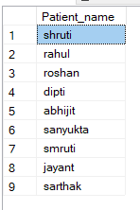

Q2. Display number of patients treated by the same doctor and in the same ward.

Output:-

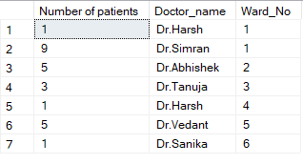

Q3. Display the average fees taken by each Doctor.

Output:-

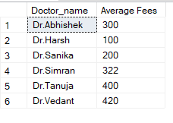

Q4. Which specialist has used the maximum number of injections on date ‘01-02-22’?

Output:-

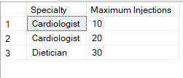

Q5. How many nurses were present on Wednesday with Dr.Rutuja?

Output:-



Q6. At what time is Dr.Rutuja available on Wednesday?

Output:-



Q7. Count of patients with good condition treated by each doctor?

Output:-

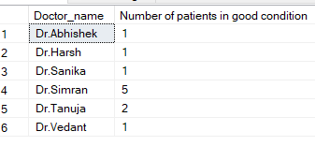

Q8. Wards on which floor has used the minimum number of medicines on date ‘02-02-22’?

Output:-



Q9. Display ward no. having minimum number of beds.

Output:-



Q10. Display total experience of doctors with specialty as ‘Cardiologist’.

Output:-



Q11. Display Doctor names and their corresponding floors.

Output:-

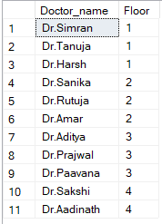

Q12. Display average Number of beds on each floor.

Output:-

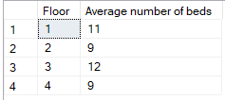

Q13. Display Doctor names and their ward numbers from Patients and Timetable.

Output:-

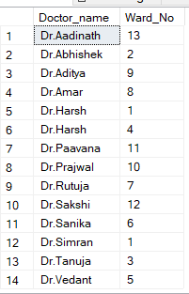

Q14. Display count of patients treated on each day.

Output:-

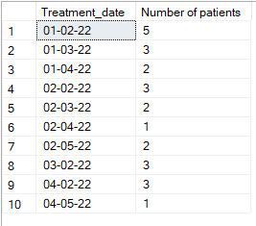

Q15. Display count of patients from each condition type.

Output:-

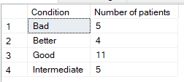

Q16. Display the total number of injections and medicines used by each doctor for doctor having doctor id greater than 3?

Output:-

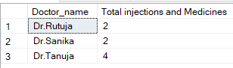

Q17. Display the medicines consumed on each day starting from most to least.

Output:-

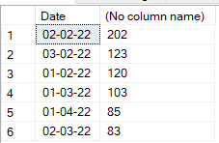

Q18. Which ward has treated the most number of patients who went in good condition?

Output:-

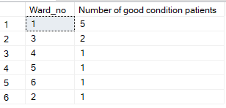

Q19. Give the doctor specialities available at 10am.

Output:-

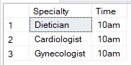

Q20. Display the number of nurses using more than 20 injections in each ward.

Output:-

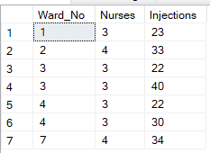

Q21. Display number of patients treated by doctors having more than 3 years of experience in each ward.

Output:-

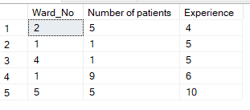

Q22. Display the contact nos. each patient should contact in case of further assistance.

Output:-

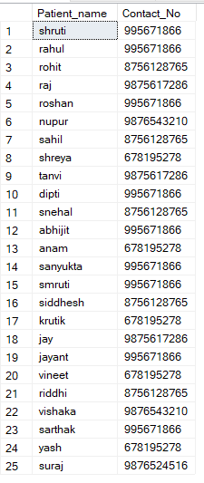

Q23. How many doctors are available at each time of the day?

Output:-

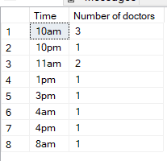

Q24. Display Doctor_ID and names treating patients having 's' as their initial.

Output:-

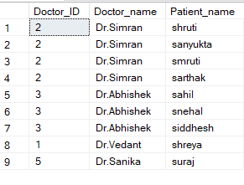

Q25. Which doctor can see a patient if Dr. Simran is not available?

Output:-

